

September, 27, 2015

**VanosGISC9231-D1**

**GISC9231 Remote Sensing**

**Travis Vanos**

***Image A24284-69: St. Catharines***

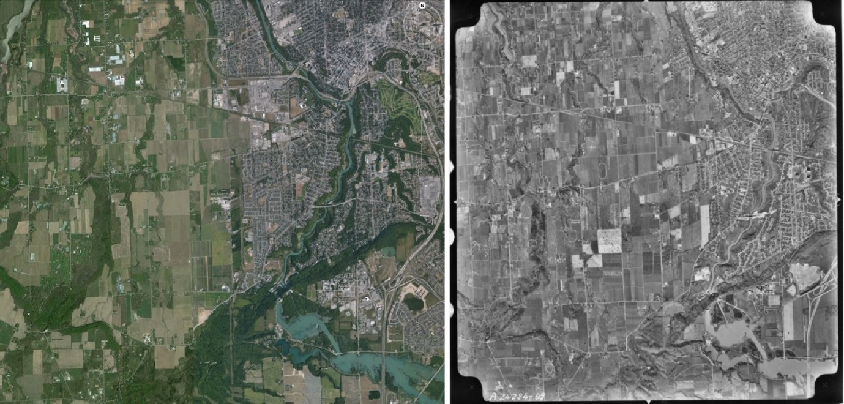

(Figure ) Current Google Earth Aerial Photography1 vs Historic Department of Energy, Mines and Resources Panchromatic

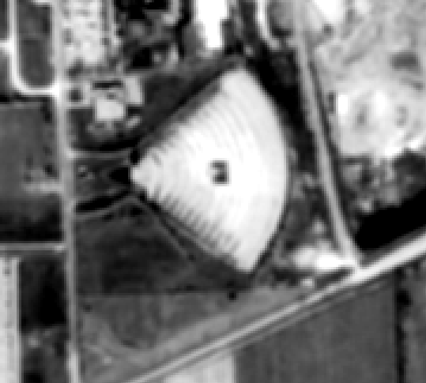

Figure M07 (Historic Department of Energy, Mines and Resources Panchromatic)

1. What is the triangular feature at the lower left corner of grid location M07? (3 marks)

|  |  |
| --- | --- |
| Elements | Interpretations |
| Tone | The feature in question is light-toned in nature. Since the tone is much brighter than close objects and nearby farmland, this would cause belief that this soil is topographically higher or significantly dryer. |
| Shape | The aforementioned object is very large and unique in pattern and shape2. A man-made cone-like shape with a rounded back with a single road entering it2. With the relative size to nearby roads, vehicles and buildings, the feature greatly resembles a drive in theatre2. |
| Size | Observing the large size of this feature compared to other features’ sizes including: parking lot sizes, road sizes and relative size to cars would lead to the assumption this object is consistent with a drive-in-theatre2. |
| Pattern | With a unique shape the feature has no formality with relative objects. The object also exhibits no obvious changes in height. Furthermore, you can observe a small building and/or projection for the screen in the theatre2. There is a pattern with scalloped concentric arcs |
| Texture | The feature has a distinct texture contrasting to the surrounding ground. With a more uniform texture this feature is flat and roughly a similar surface to a road. |
| Shadow | No large shadow can be seen from the feature which would mean the feature has little height and is relatively flat. |
| Association | With no significant residential or commercial area in the vicinity, this would lead to the assumption only cars would be used to get to this feature. A small road is entering through the rounded curve of the object likely used for cars to access the theatre. |

**Interpretation: Drive-In Theatre 2.5/3**

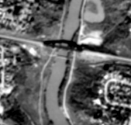

Figure K15 and L15 (Historic Department of Energy, Mines and Resources Panchromatic)

1. What is the dark linear feature crossing the border of K15 and L15? (3 marks)

|  |  |
| --- | --- |
| Elements | Interpretations |
| Tone | The feature in question is very dark toned and non-reflective. A solid structure built in an engineered manner would lead to the assumption this steel or other hard painted metal that absorbs light. |
| Shape | The dark object is a uniform, symmetrical shape that has no closed sides and spans the distance of the cleared way on either side. |
| Size | The feature in question is large, spanning roughly the length of several adjacent residential houses. The width is the same as the pathway cleared on either side of the river. A dark tone and large shape would lead to the assumption this is a bridge. |
| Pattern | With open sides, uniformity and its dark tone you can tell this is a built structure from steel or similar hard, painted metal. With the purpose of spanning the width of the river the bridge is an expected sight connecting the cleared-way. |
| Texture | With a much darker tone and clear uniformity in colour the texture is consistent with that of steel or other painted hard metal. |
| Shadow | The feature is casting a shadow underneath causing further affirmation that the structure is a bridge spanning two points. |
| Association | Clearing the obstacle the bridge has a clear association with the cleared pathway on either side of the bridge. Where is your graphic? 2.5/3 |

**Interpretation: Train Bridge**

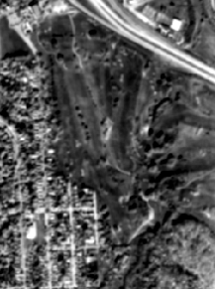

Figure N18 (Historic Department of Energy, Mines and Resources Panchromatic)

1. What is the large feature (part of which is in the bottom left of N18)? (3 marks)

|  |  |
| --- | --- |
| Elements | Interpretations |
| Tone | The large feature in question has a darker tone and is consistent some portions of farmland and residential areas that has been well watered. |
| Shape | With a large cleared space the feature has no similar pattern or shape features in the vicinity. This would lead to the assumption this feature is fairly uncommon and identifiable. |
| Size | The feature is quite large spanning several neighborhood blocks. A tone similar to that of crops but without the uniformity. |
| Pattern | The feature spans a large area with no drastic change in height. The contrasting grass tone and narrow length of each lighter grass patch would coincide with a golf course. A few deciduous trees and possibly sand are sparsely present throughout the object except of the lighter patches of fairway grass which further affirms the notion of a golf course. |
| Texture | Present in the object is a speckling of deciduous trees that are evenly round and a rougher surface than that of the surrounding grassy areas. The lighter patches present an even tone and hence a smother surface. |
| Shadow | The objects size is that of something large and flat with no height to cast a visible shadow. There are shadows associated with trees in the area |
| Association | With an area of this size, relatively accessible access from nearby residential areas and seemingly intentional sparse deciduous trees would indicate the feature is a golf course |

**Interpretation: Golf Course 2.5/3**

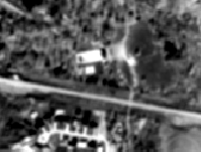

Figure N15 (Historic Department of Energy, Mines and Resources Panchromatic)

1. What is the white square at the bottom of N15? (3 marks)

|  |  |
| --- | --- |
| Elements | Interpretations |
| Tone | The feature in question has a bright tone and contrasts significantly against surrounding foliage. Darkening the colour spectrum yields an even more vibrant object. The tone would resemble something highly reflective such as something white in colour or shallow water. |
| Shape | The shape is a rectangular, man-made feature that has a relative size to about two nearby residential houses. |
| Size | The feature is an easily spotted feature with a relative size to approximately two residential houses in the vicinity. |
| Pattern | With a unique shape the feature has no formality with relative objects and looks out of place in the surrounding tree cover. The object also exhibits no obvious changes in height. At first glance the feature could resemble a rectangular club-house to the neighbouring golf course but the bright tone resembles a more reflective object. |
| Texture | The feature has a distinct texture contrasting to the surrounding ground. With a drastic change in texture and tone would coincide with a man-made object such as a pool. |
| Shadow | With no visible height or topographical change the feature here would not cast a shadow. Contrary to this the object is flat and possibly below ground and not to be mistaken for a building with a reflective surface that would cast a shadow. |
| Association | With the fact that the object is in a reasonable distance from the adjacent golf course at first glance this may appear to be the golf clubhouse. The road and parking lot would coincide with a building but after examining the tone and texture the more accurate solution would be parking for the pool. |

**Interpretation: Swimming Pool 3/3**

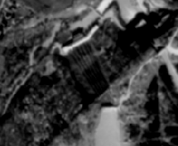

Figure G06 and H06 (Historic Department of Energy, Mines and Resources Panchromatic)

1. What are the linear features crossing the border of G06 and H06? (3 marks)

|  |  |
| --- | --- |
| Elements | Interpretations |
| Tone | The feature crossing the border between G06 and H06 has darker tones in evenly spaced lines. The feature resembles fuller, more water-absorbed plant matter than that of the surrounding ground. With little light reflecting the feature could also be present in a uniform order that is a dark tone and non-reflective. |
| Shape | The shapes covering the borders of the two cells are even and obviously man-made, linear in shape the structure pattern is too clean for natural occurrence. |
| Size | The feature spans a large cleared area that resembles a cleared patch for farmland. A large clearing has been made in the surrounding deciduous trees and each line in the feature is a little narrower than a single tree crown. |
| Pattern | The feature exhibits an even pattern like that of a plowed field. Longer evenly spaced rows for organized crop placement. The lines, however are not perfectly evenly spaced which seems unusual for this pattern if it was, in fact, lines of crops. |
| Texture | With the subtle variations in colour and unevenness in tone the texture resembles that of very moist foliage or that of a dark, unreflective surface. |
| Shadow | In the feature, the lines present no visible shadow. However, the nearby white building bordering the vineyard is casting a larger shadow and on the edge of the water an even bigger shadow can be seen indicating a major change in topology and height. |
| Association | A cleared, flat area cleared in a deciduous tree area would be expected characteristics for farmland or crops. Away from major residential areas and in the vicinity of a water source can also be seen as an indicator to farmland. However, with this said the area is in fact too close to the water and on too much of a slope to be used for viable farmland. A wall must be present or man-made barrier for the neighbouring lake. |

**Interpretation: Hydro dam 3/3**

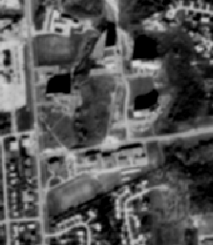

Figure M13 (Historic Department of Energy, Mines and Resources Panchromatic)

1. What is the large polygonal/linear feature crossing near mid-border of M13 and N13? (3 marks)

|  |  |
| --- | --- |
| Elements | Interpretations |
| Tone | With no significant change in tone, the tops of these buildings can be hard to distinguish between the surrounding grounds. However, an outline of the rooftops can be seen and darker objects of the roof can be recognized by the slightly contrasting tone. |
| Shape | The feature in question is an elongated polygon with straight sides man-made. Appearing to be a series of connecting square and rectangular buildings with varying heights. |
| Size | The building(s) are fairly large and exhibit enough height to cast a clearly visible shadow. The entirety of the structure spans almost twice the length of the nearby football field and approximately the same width. With an uneven shadow one can tell that the building has a varying height in attached buildings. |
| Pattern | This feature presents clean cut lines of attached rectangular and square buildings with no reoccurring pattern. |
| Texture | Although the assumption can be made that the buildings roofs would be flat, there are clear changes in texture as you notice different objects on the roof that present a different, contracting tone. These could be A/C units or other building utilities fixed on the roof. |
| Shadow | On the north side of the structure a clear line of shadows can be seen at a varying heights indicating the structure is unevenly topographical in its entirety. |
| Association | The feature in question is in close proximity to many objects that would indicate this would be a school. With its close proximity to nearby residential areas, apartment buildings and roads this is a structure accessible to a family demographic. A large football field can also been at the back of the structure further affirming the notion of a school. |

**Interpretation: School Building 3/3**

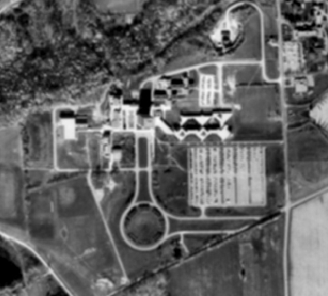

Figure K07 (Historic Department of Energy, Mines and Resources Panchromatic)

1. What are the features at the bottom of K07? (3 marks)

|  |  |
| --- | --- |
| Elements | Interpretations |
| Tone | Seemingly contained in a large plot, the entirety of the complex has several variations in tone. Surrounded by many different soil types you clearly identify the change in tone for the fields, road, buildings and parking lots. |
| Shape | In this feature, some obvious characteristics can be noted solely on the premise of their shape. The large, flat rectangular section with a tone similar to that of a road can be easily identified as a parking lot. The numerous roads can be seen to access the main portion of the buildings. |
| Size | Seemingly one continuous complex, the feature spans a large distance utilizing a complementing set of roads, parking areas, buildings, trees, etc. By comparing the size to surrounding objects such as cars, residential areas and fields, you can determine the feature, as a whole, has an area of many Kilometers. |
| Pattern | In the complex, there is no one asserting building but rather a series of buildings with varying shapes joined in a single large complex. In the center of the feature an unnecessarily large round about is present as a focal point of the complex. |
| Texture | In the entirety of the complex a range of textures can be seen when comparing the different rough and smooth surfaces present. The fields in the surrounding vicinity have varying textures and tones indicating the different is soil composition. Smooth surfaces such as the roads and parking lot can be distinguishable from the cleared areas and surrounding tree line. |
| Shadow | Looking at the complex of buildings a number of shadows can be seen varying in height and width. The largest of the towers casting the greatest of the shadow one can determine it is the largest building on site |
| Association | This is a feature spanning a large area with the focal point on road design and large parking lot. One can determine the majority of the users will be driving and hence, older and in the money making range. |

**Interpretation: Brock University 3/3**

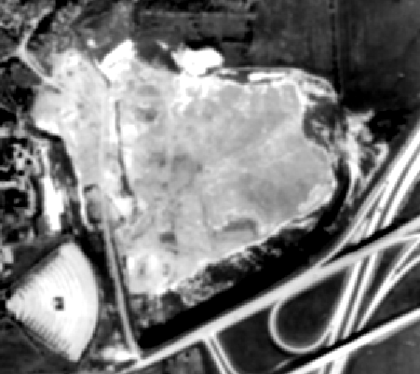

Figure M08, N08, M07, N07 (Historic Department of Energy, Mines and Resources Panchromatic)

1. What is the large feature centered on M08, N08, M07 and N07? (3 marks)

|  |  |
| --- | --- |
| Elements | Interpretations |
| Tone | In the span of the object a single, uniform tone is present with little variation throughout. Contrasting to the nearby watered crops you can determine this is a dryer patch of ground. |
| Shape | This feature is a large, flat, extensive piece of land that has no obvious change in topography. |
| Size | In relation to Question 1, the drive-in theatre the area spans an even larger area indicating more of a park or ecological conservation area. |
| Pattern | The feature has no distinct patterns or borders. The area is unique in both pattern and shape instilling reason this would be naturally occurring as opposed to man-made |
| Texture | The area has a contracting texture to the bordering farm-land and tree line. A seemingly smoother surface with a brighter tone would indicate a flatter more dry soil area. |
| Shadow | No shadow can be seen indicating there is no height or change in topography associated with the area. |
| Association | A large area of this size and natural formation would indicate an intentionally preserved park or simply un-developed city land. |

**Interpretation: Conservation area/park It is a quarry 3/3**

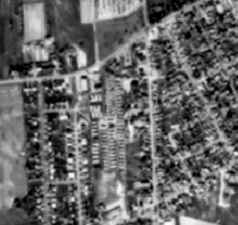

Figure H14 (Historic Department of Energy, Mines and Resources Panchromatic)

1. There are numerous small features in the middle of H14, (not along roads) – What are these features a part of? (3 marks)

|  |  |
| --- | --- |
| Elements | Interpretations |
| Tone | In the object each smaller object has a varying tone from the adjacent indicating the smaller objects are not completely uniform in design. The objects are more reflective and would contrast to trees or other soil. The area has no abundance of foliage and therefore no great contrast can be seen between the trailers and the ground. |
| Shape | The small, uniform objects are all of the same general shape of elongated rectangles. |
| Size | The objects are smaller and more compacted especially compared to nearby residential blocks. On an individual scale each of the mobile homes is about half the size of a residential house. |
| Pattern | The objects are laid in a uniform pattern in organized rows. With such uniformity the mobile homes resemble a smaller grid pattern. |
| Texture | The area in which these objects lie on can be seen as flat with an even texture. The smaller gridded objects show variations in brightness throughout an would be rougher in texture. |
| Shadow | In the feature, looking closely some faint shadows can be seen on each of the smaller objects. The objects do have some height but do not produce a shadow like that of their residential counterpart, houses. |
| Association | The feature, fixed between housing neighborhoods would indicate this area is still used for residential purposes. With the compact size and grid-like pattern the area greatly resembles that of a mobile-home/trailer park. |

**Interpretation: Mobile Home/Trailer Park 3/3**

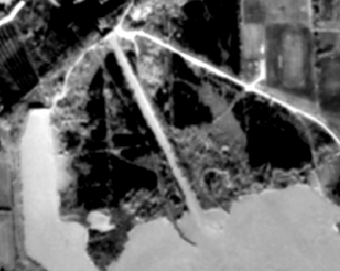

Figure H05 (Historic Department of Energy, Mines and Resources Panchromatic)

1. What are the dark patches in H05 (3 marks)

|  |  |
| --- | --- |
| Elements | Interpretations |
| Tone | The feature at H05 presents very dark features very close to the water source. The feature resembles fuller, more water-absorbed plant matter than that of the surrounding ground. |
| Shape | The shapes present resemble that of something natural such as naturally occurring tree growth sections. |
| Size | The feature spans a large area seemingly overgrown with no un-natural order. A large plane around the lake with darker tones indicated the ground is much more water-logged and therefore less reflective. |
| Pattern | With seemingly no order the feature resembles that of natural tree grown or stagnant, trapped water. |
| Texture | With the subtle variations in colour and unevenness in tone the texture resembles that of very rough, moist foliage or that of a dark, unreflective surface. |
| Shadow | In the feature, the uneven shapes present no visible shadow. No shadow can be seen on the road or nearby ground which would indicate these are not trees. |
| Association | With the dam, previously identified, so close and the lake seeming full these shapes can be associated with excess, stagnant water rather than naturally occurring foliage. |

**Interpretation: Flooded plain it is a regenerated forest area - dark tone indicates that there is healthy vegetation 2.5/3**

***Image A19358-75: Queenston***  
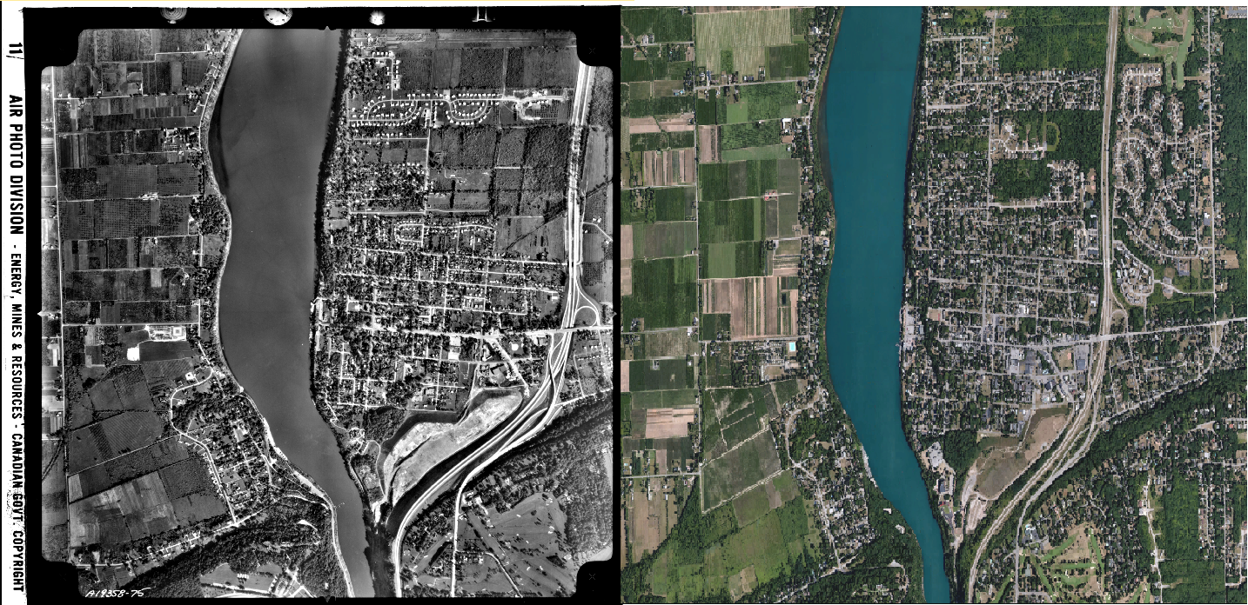

Figure Google Earth Imagery1 vs Historic Department of Energy, Mines and Resources Panchromatic

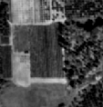

Figure Location A (Historic Department of Energy, Mines and Resources Panchromatic)

1. What is the feature at location a? Why is it darker than similar features (features of the same type) located near by (4 marks)

|  |  |  |
| --- | --- | --- |
| Elements | Interpretations | |
| Tone | The feature present exhibits a darker tone even contracting to the obvious farm-land bordering. | |
| Shape | This feature is a large, flat and man-made. With the even pattern and linear borders it is clear this is plotted farm land. |
| Size | The feature itself is not a drastic change from the other farmed plots in the area. Several acres in area this is an expected size. |
| Pattern | The feature exhibits a pattern congruent to the made-maintained areas of agriculture throughout the region |
| Texture | With a subtle variation of tone throughout the matter resembles non-reflective foliage. Similar with all other types of plant matter the object can be assumed to be rough. |
| Shadow | Shadows can be spotted providing some cover to a small portion of crops. The agricultural area presents no visible shadows and in turn, is flatter. |
| Association | In an area surrounded by agricultural expanse with the same pattern, through association you can identify this as an agricultural expanse. The clean cut boundaries and uniformity coincide with all known crop yields of the area. |

*The feature in question presents a darker tone because the wetter, damper plant matter is non-reflective. Absorbing more light than that of roads, grass and even other types of crops. This is useful to note because different agricultural crops will absorb more water than others and in turn provide us with some clue as to what is growing there. Indicative of healthy vegetation 4/4*

***Interpretation: Agricultural land***

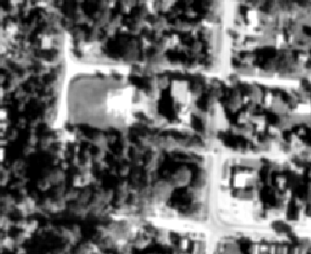

Figure Location B (Historic Department of Energy, Mines and Resources Panchromatic)

1. What is the feature at location b? What is the dark shape on the left part of this feature? What does this tell us about the feature (4 marks) 4/4

|  |  |
| --- | --- |
| Elements | Interpretations |
| Tone | The feature contains one building and a field with a lighter tone. No varying tone throughout either indicated both are relatively smooth in texture |
| Shape | A building in an obvious square shape and a field make up the entirety of the complex; a elongated rectangle plot of land. |
| Size | I relation to nearby housing and residential area you can determine the building is larger than most residential structures and the field, as expected, is larger than a lawn in the relative vicinity. . |
| Pattern | The feature has a single shape and hence no reoccurring pattern. With a clean shape and surrounding road the feature is meant to be visible. |
| Texture | With no drastic variations in tone throughout the building and field the texture in both is relatively smooth. |
| Shadow | A larger shadow can be seen from the main school building. With more shadow present the building has more height than neighboring residential houses. The dark shape to the let of the building is in fact the shadow being cast by the building onto the grounds. |
| Association | In an area surrounded by residential housing and clearly visible one can gather this is a school or church serving the community. |

**Interpretation: School/church**

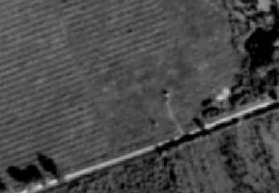

Figure Area C (Historic Department of Energy, Mines and Resources Panchromatic)

1. What is the small object at the centre of area c? Be sure to discuss the context (association)

*The object located here can be seen as a large, tall antenna and/or radio tower. Located in the field to service, whatever the utility may be, the surrounding area. The main reasoning for this assumption is the context in which this object is present. The object, though large, will not be seen by many and will serve a more practical purpose than that of visual looks or style. Also through association you can notice a single service road used by technicians/maintenance when working on the tall, slim, structure.*

**Interpretation: Radio antenna/tower you still needed to go through all the characteristics of interpretation - long thin shadow extending from small boxlike shadow 1.5/3**

1. What is the linear feature in area d? (5 marks)

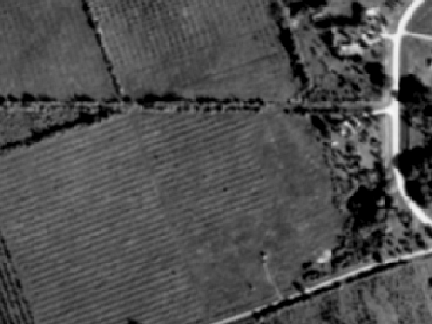

Figure Area D (Historic Department of Energy, Mines and Resources Panchromatic)

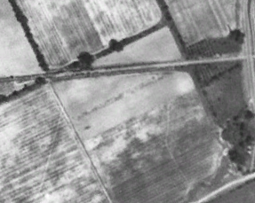

Figure Google Earth Historic Imagery (1934)

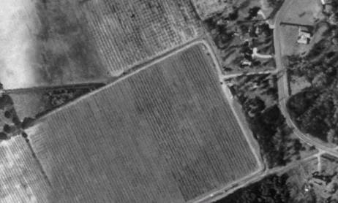

Figure Google Earth Historic Imagery (1995)  
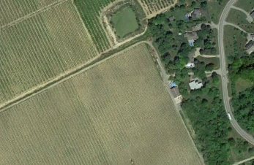

Figure Google Earth Imagery (2015)

*Looking at historic imagery on Google Earth has yielded the result that this is a portion of historic trail (Bruce Trail). A darker, rougher textured tree line can be seen with a noticeable break in the trees for the cleared path. The tree line does in fact cast a shadow and therefore larger deciduous trees are present. Athough the path is cleared, it can easily be mistaken for a road but looking at surrounding dirt roads shows this path as slightly smaller. In Figure 17 you can see the path clearly defined and cleared. Progressing further to 1995 (Figure 18) you can notice the path has now been broken but the two sections on either end still remain until after which the path was completely erased and re-purposed into viable farm-land at some time after 1995.*

***Interpretation: Bruce Trail look at the long sweeping curve indicative of a rail line; overgrown by shrubs; small shadow which could mean slight depression; 3.5/5***

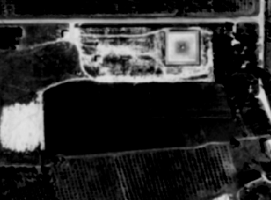

Figure Area E (Historic Department of Energy, Mines and Resources Panchromatic)

1. What is the square feature in area e? Why is it so bright? (4 marks)

Presentation/Grammar/Spelling: include your letter inside the document; summarize your findings in your letter; work on your usage of the comma; 8.5/12.5

*The feature is a current swimming pool. At the time of this panchromatic imagery the pool may have been under construction or closed for the season because of how reflective the object is. Water, generally, tends to absorb light where this pool and present a darker tone. Although the object has the proper shape, size and proportions of a pool, you can determine it has no water in it because the insides of pools tend to have white or blue, smooth tile or lining that would be more reflective. Surrounding the pool appears to be roads or dirt trails perhaps used for construction of the resort. There are rough markings for roads and what appears as a temporary parking lot . Water absorbs IR so it would be dark; this bright tone is due to the reflective nature of building materials. 2.5/4****Interpretation: Shallow or empty pool***

Questions: 43.5/50

Total: 52/62.5